Heather
We had just lost Scooch and although we had three other special-needs dogs living with us, the house felt empty without this amazing soul who always gave his all to us. We didn't especially want to adopt any more dogs, but a call came in from Los Angeles about a blind bichon-cocker mix who had been found on the streets of east L.A. Since we were scheduled to be in California the following week for a health expo, we agreed to take her home with us.
A confirmed pack dog, Heather loves spending time with her brothers and sisters. Although she can't see what's going on with her sighted companions, she jumps into the fray whenever she hears the romping as though she can see everything -- often causing more chaos than fun! Even so, she seems comfortable in her surroundings and with the pack, and despite having very few teeth has no trouble eating whatsoever. She's great on a leash and simply loves to love and to be loved.
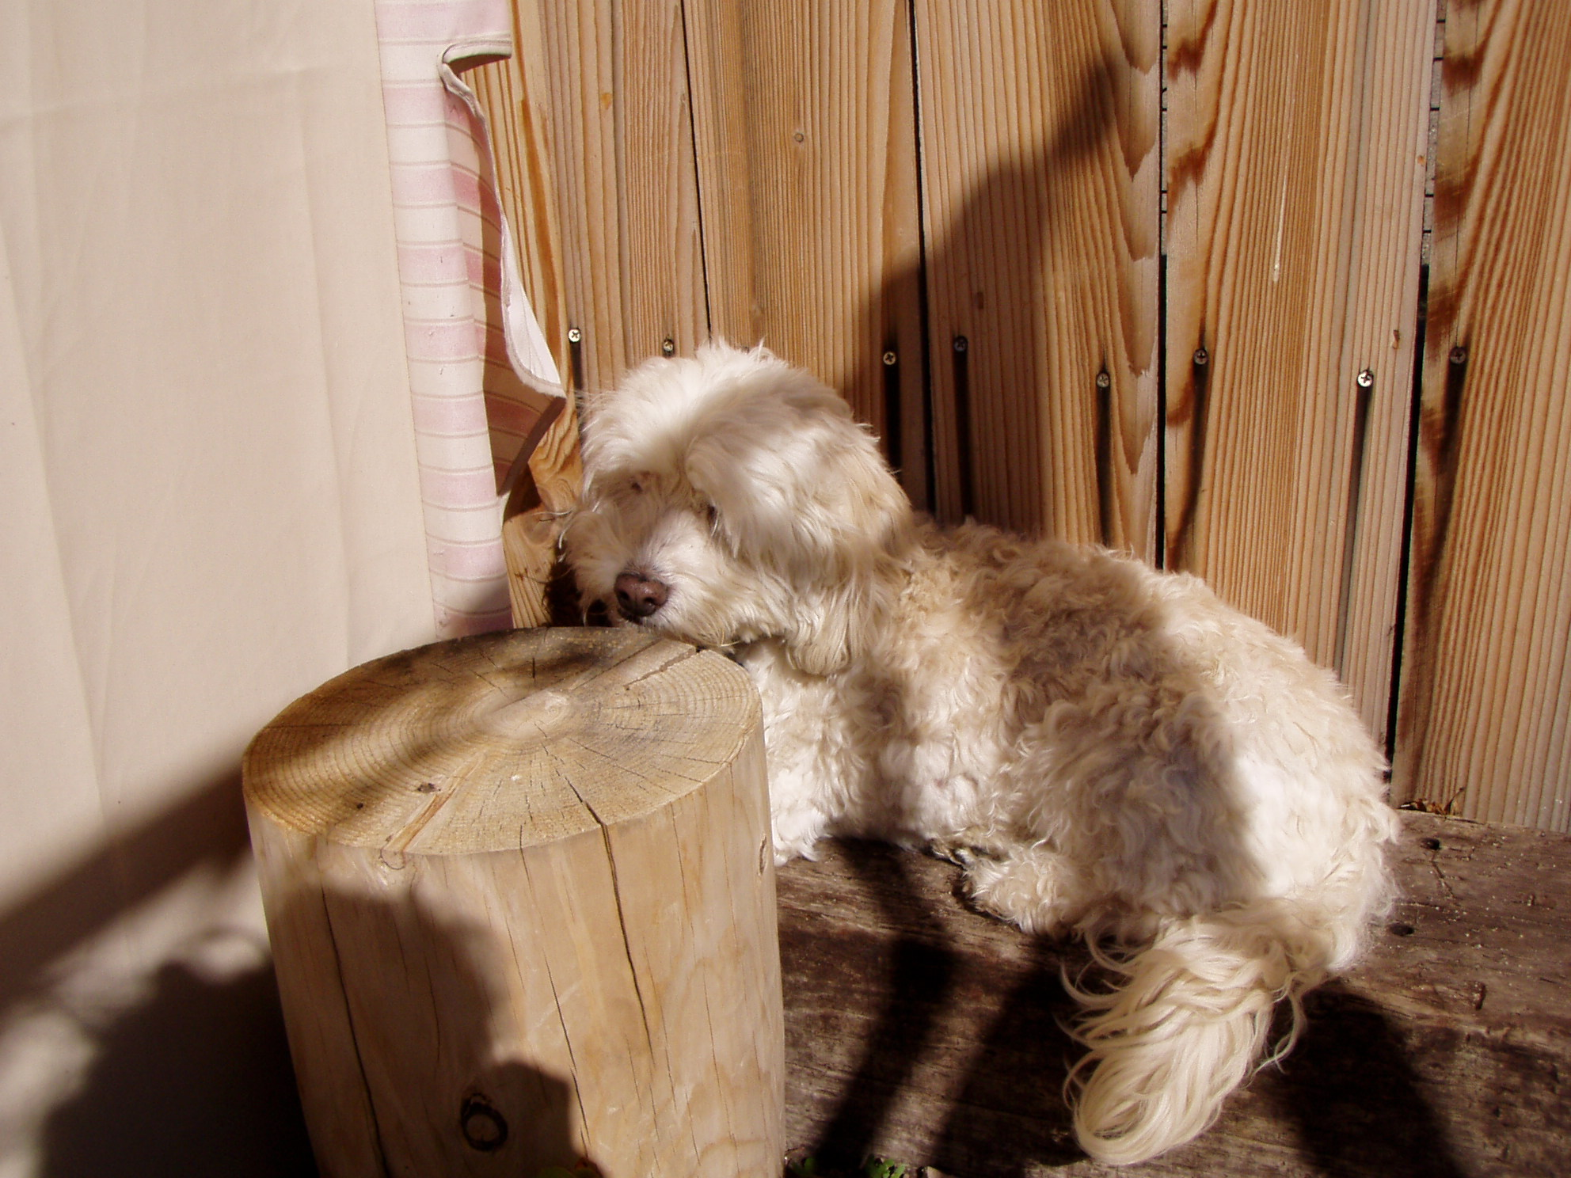 Heather hanging out in a corner in the backyard. Since she can't see us, obviously we can't see her, right? No one knows she's there....
Please help Dr. Bera care for lost, injured and sick animals!
Click here to make a donation through Voice for a Choice!

