Hercules
"He's so badly damaged we'll just have to have him put to sleep. Get dressed and let's take him to the pound." This is what the breeder told her young daughter after she stepped on the 5-week-old yorkie-poo and broke both front legs and right shoulder, left hind leg and left hip. The daughter cried and asked her mom to help this poor little creature, but she refused her. "It's just an animal," was her response.
Fortunately, many shelters and pounds have agreements with rescue organizations. The Santa Fe pound considered Hercules worthy of being rescued, so they placed a call and we ended up taking this adorable baby home. They advised us to get him a cart so he could get around. His front legs should be amputated, they said, due to the severe damage and painful breaks. Since we do bodywork on all our adoptees, we did not even consider amputation. We felt sure we could help him achieve some level of comfort, especially since he was only a puppy.
This little boy receives head-to-toe massage therapy at least 5 days a week. He has no idea he hurts until he finishes his day and crawls into a little ball whimpering and asking for his treatment. Up to then, he's very busy chasing his 5 brothers and sisters and his squeaky, talking chew toys. We also give him the homeopathic pain remedy Zeel on those days when he seems to need general maintenance. If he overextends himself, which he often does, he gets a dose of Traumeel by the same company (Heel, Inc.), which addresses more acute traumatic pains.
Hercules has a wonderful appetite, but never overeats. He stops when he feels full. His once thin coat is now full, rich and shiny black. He's gorgeous and he knows it.
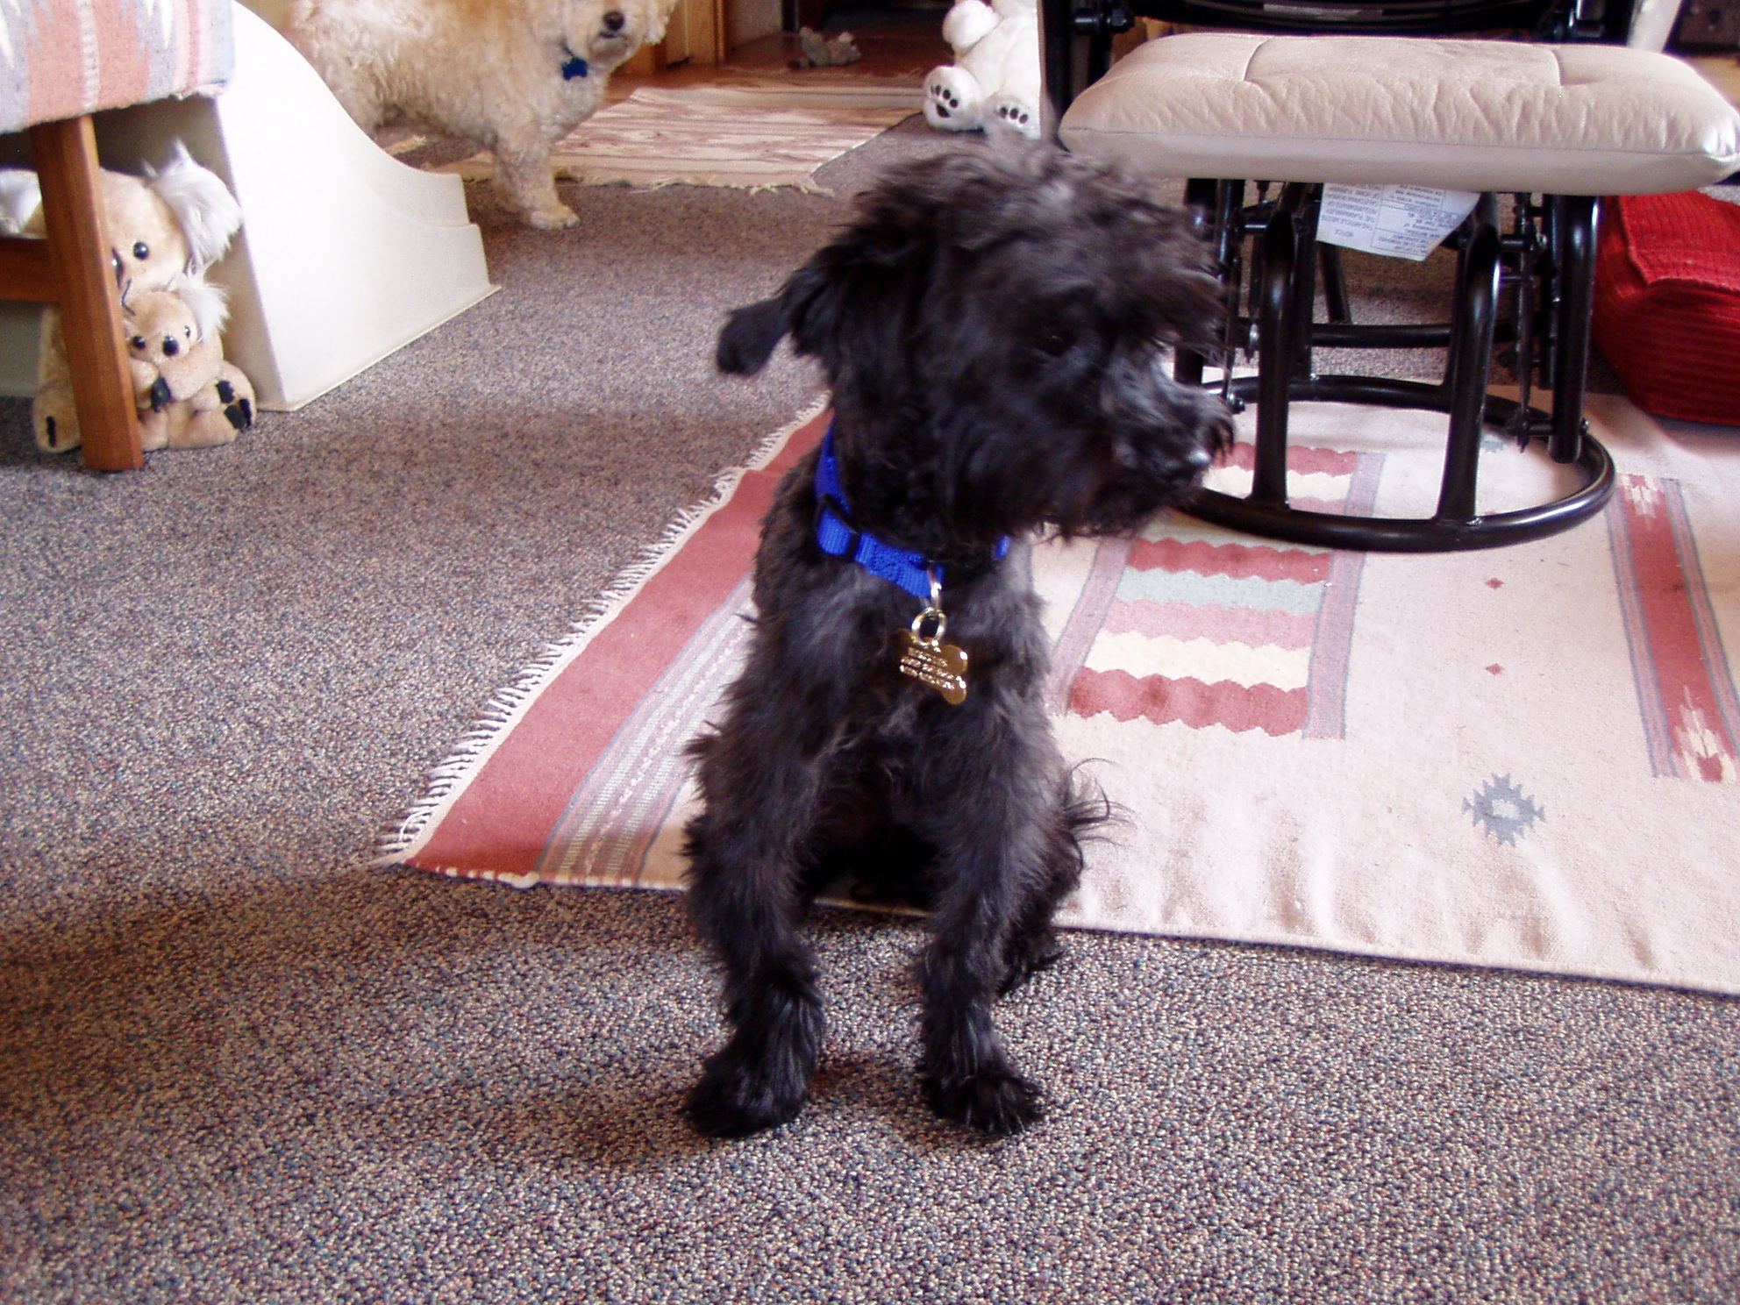Newly arrived Hercules -- skinny boy 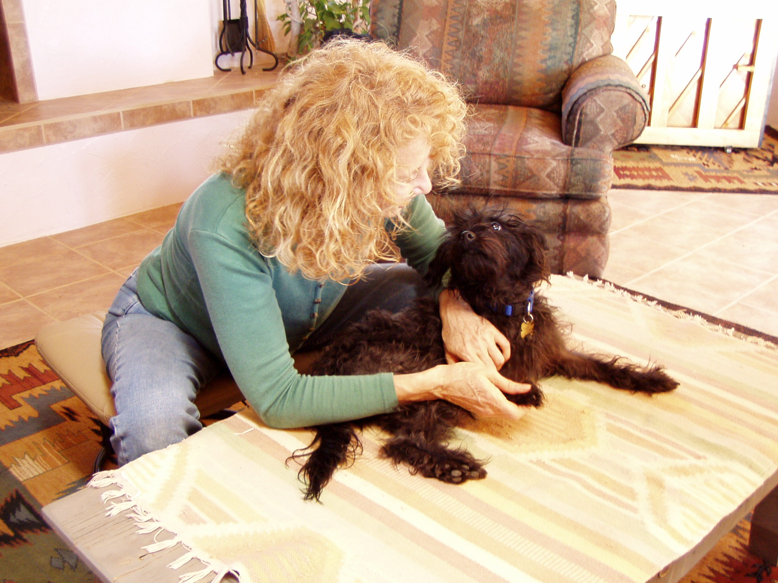Daily bodywork therapy
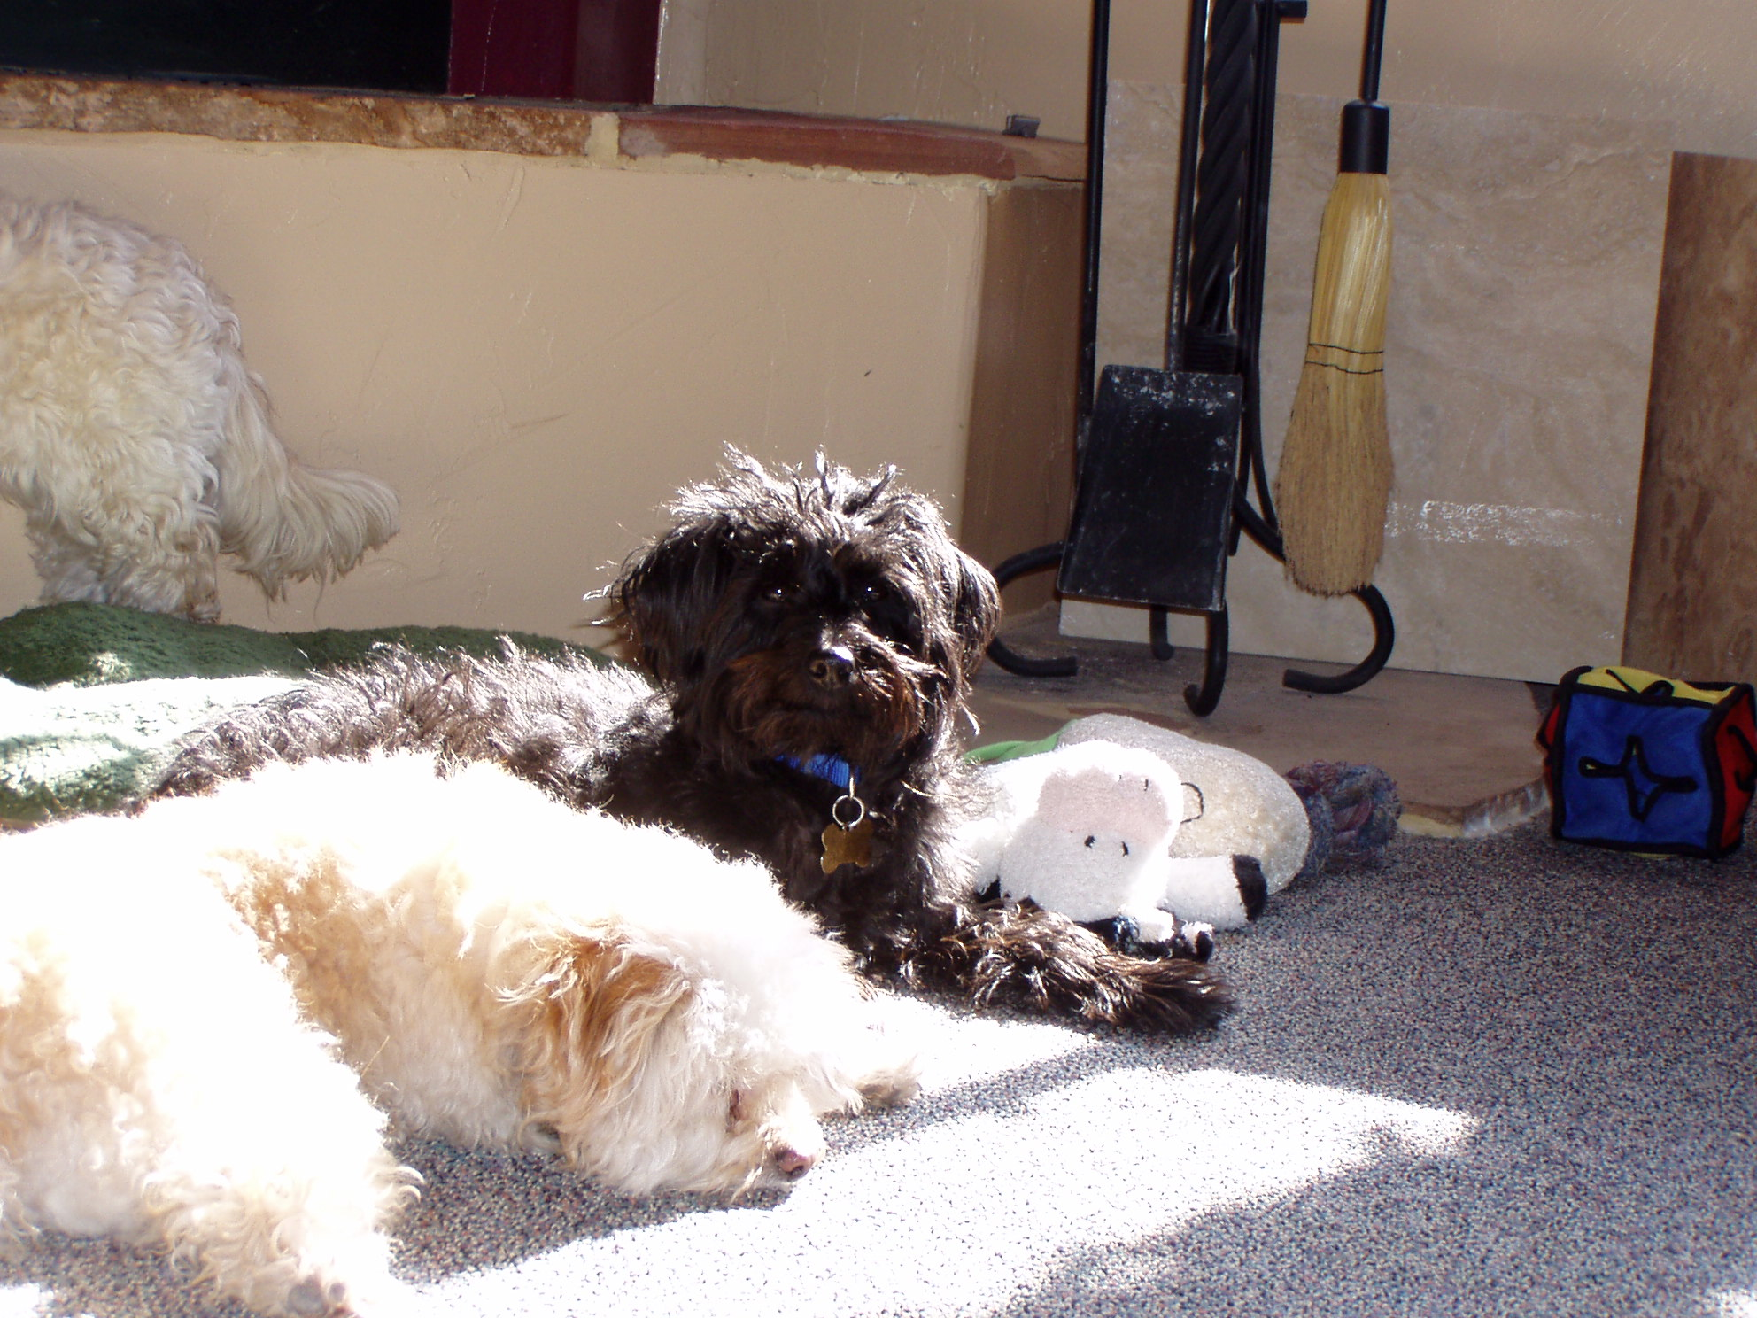Hercules & Wylie hanging out in the sun
Please help Dr. Bera care for lost, injured and sick animals!
Click here to make a donation through Voice for a Choice!

