Kushi, K'Tahna & Scooch
"Hey, Ron, since we're moving in together, can we get a dog? My sister just called about a little poodle that's been run over. She's got a broken leg and is having epileptic seizures, so the rescuer said they're having a hard time placing her. But she's only 10 months old and she really needs a good home."
"Can't we get settled in first and then consider a dog?"
"They could put her down if they don't find her a home before that happens! Please...."
And thus began our rescuing of special-needs dogs. Each with his or her own special personality traits and each with a major lesson to teach us about life, acceptance, tolerance, patience, and unconditional love. All my life I had lived with dogs, but never more than two at a time. The fascinating lessons about living with a pack were just about to begin.
Kushi, that skinny little poodle, was only about six pounds, cast and all, when we picked her up. She had a very picky appetite and no fur anywhere, because she had been shaved to check for additional injuries.
"She can sleep downstairs," Ron told me in no uncertain terms. "She absolutely will not live in our bedroom." It took all of three nights of my sleeping downstairs under the piano so Kushi wouldn't feel alone for him to relent.

Kushi actually gave us no trouble at all. She slept well on her little bed upstairs and managed to get up and down the stairs and in and out of the dog door to the backyard just fine, in spite of her broken leg.
Three weeks later K'tahna arrived. Only a little over a year old, she needed a home because her human companions were retired, loved to travel, and were constantly asking someone else to take care of her. We were delighted to have her join Kushi, and they both got so excited when they met we knew they were meant to be together. It was as if they had been best friends in a past life.

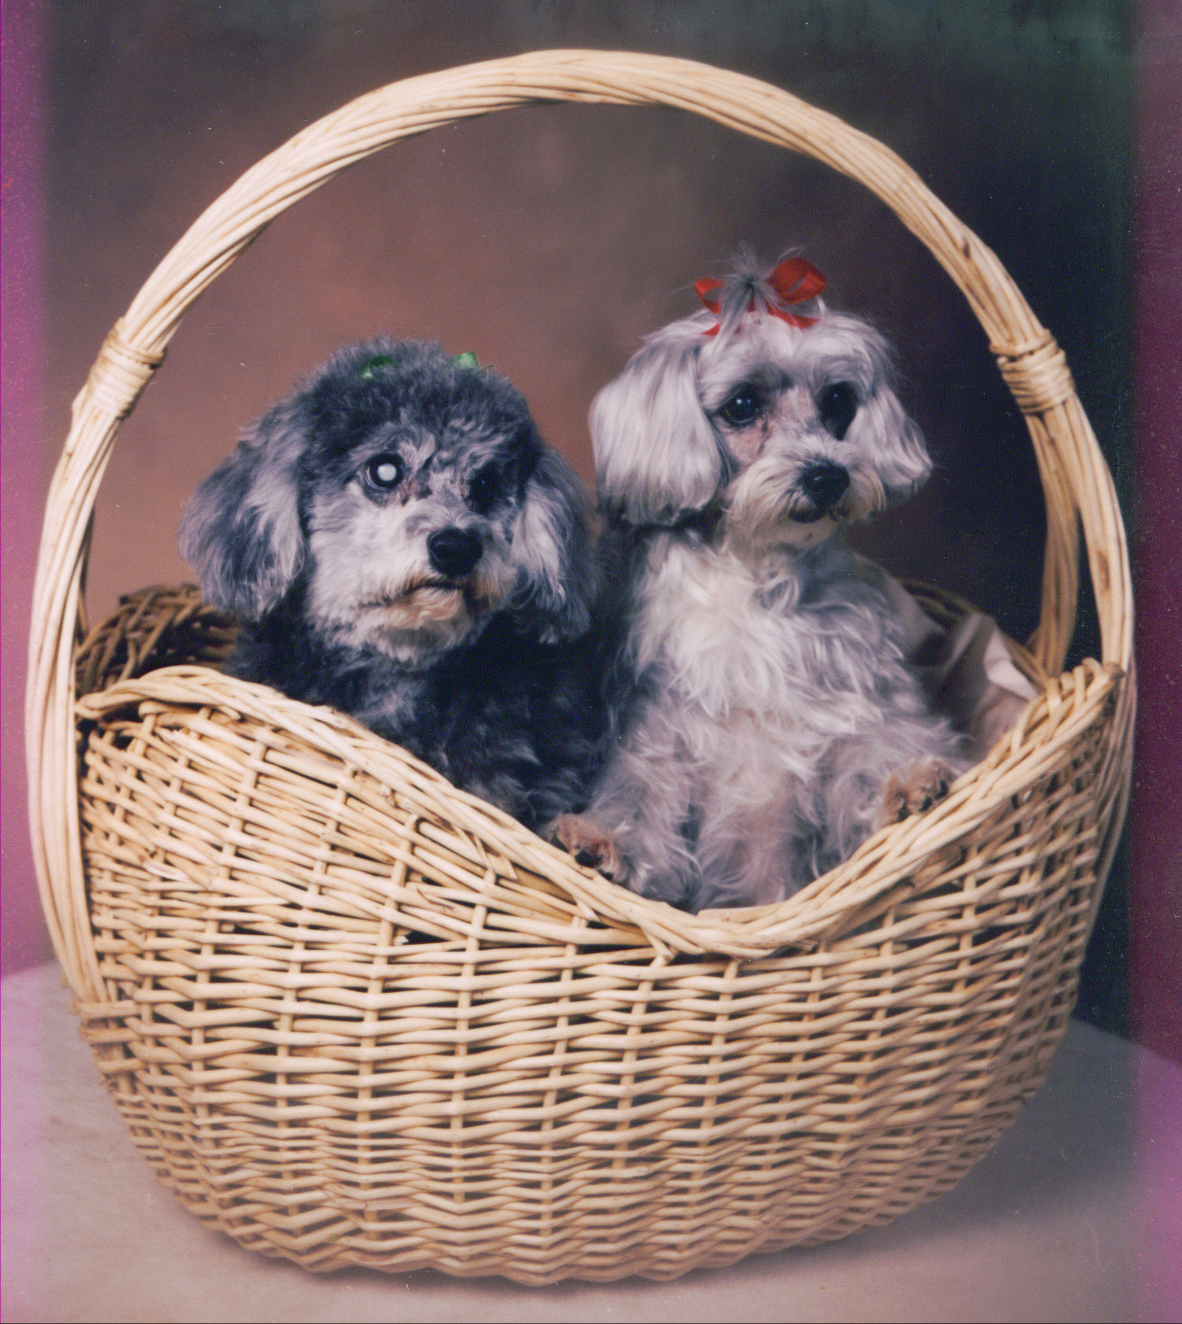

Two years later, we all moved to a new home. We loved our place and our dogs seemed to love it, too. We took long walks and met lots of neighbors with dogs. It seemed odd that so many of the small dogs were blind and so many of our neighbors had cancer, but we just figured it was a fluke. What we didn't know was that the neighborhood was only 1/8 mile from high-tension wires. We also didn't know about the dangers of electromagnetic fields--but we were soon to learn.
After about 18 months in our new location, we went to my folks' house for Thanksgiving. K'tahna promptly walked directly into my parents' pool. She seemed as shocked as we were. The following day we took her to an eye vet who told us that she had no retinal activity in the back of her eye and was completely blind. He had no idea what could have caused it.
Ron and I placed stuffed animals around all the furniture legs so K'tahna wouldn't hurt herself when walking through the house. Two and a half weeks later, while we were still adjusting to her blindness, Kushi walked straight into a wall. The vet said her eyes looked exactly like Kushi's. Again, he had no explanation for why two dogs would go blind within three weeks of each other. That was taking togetherness just a little too far!
We were referred to Dr. Bob Anderson, a vet from Oregon who traveled the country performing acupuncture on racehorses. Within 10 seconds of examining both dogs' eyes he stated, "You live under high-tension wires." When we confirmed that fact, he
explained that the dogs' retinas were 'fried' from living in the vicinity of such a powerful electromagnetic field. These fields, he told us, are hardest on young children, seniors and small animals. No wonder so many of our elderly neighbors had cancer and their dogs were blind.

Then he said, "You're next." Needless to say, we moved. Very quickly.

When she reached 17 years, K'tahna departed this world, leaving Kushi to mourn
her severely. For weeks we searched the pounds and shelters for an older dog who would get along with Kushi, but when we introduced them to one another they ignored each other. After the beautiful relationship she had with K'tahna, Kushi wasn't interested in just any companion -- it had to be the right one.

Three weeks after our loss, a shelter in east L.A. called about a blind bichon with an acid-burned rear end who had been rescued from a crackhouse. We took Kushi to
meet him -- they instantly bonded!

Scooch was about 10 adorable years old. I was still brokenhearted over K'tahna, so I promised myself that although I would adopt him for Kushi's sake, I would definitely never love him. I wasn't going to go through that kind of loss again.

It took all of 20 minutes for me to be head-over-heels in love with Scooch. I was in real trouble.
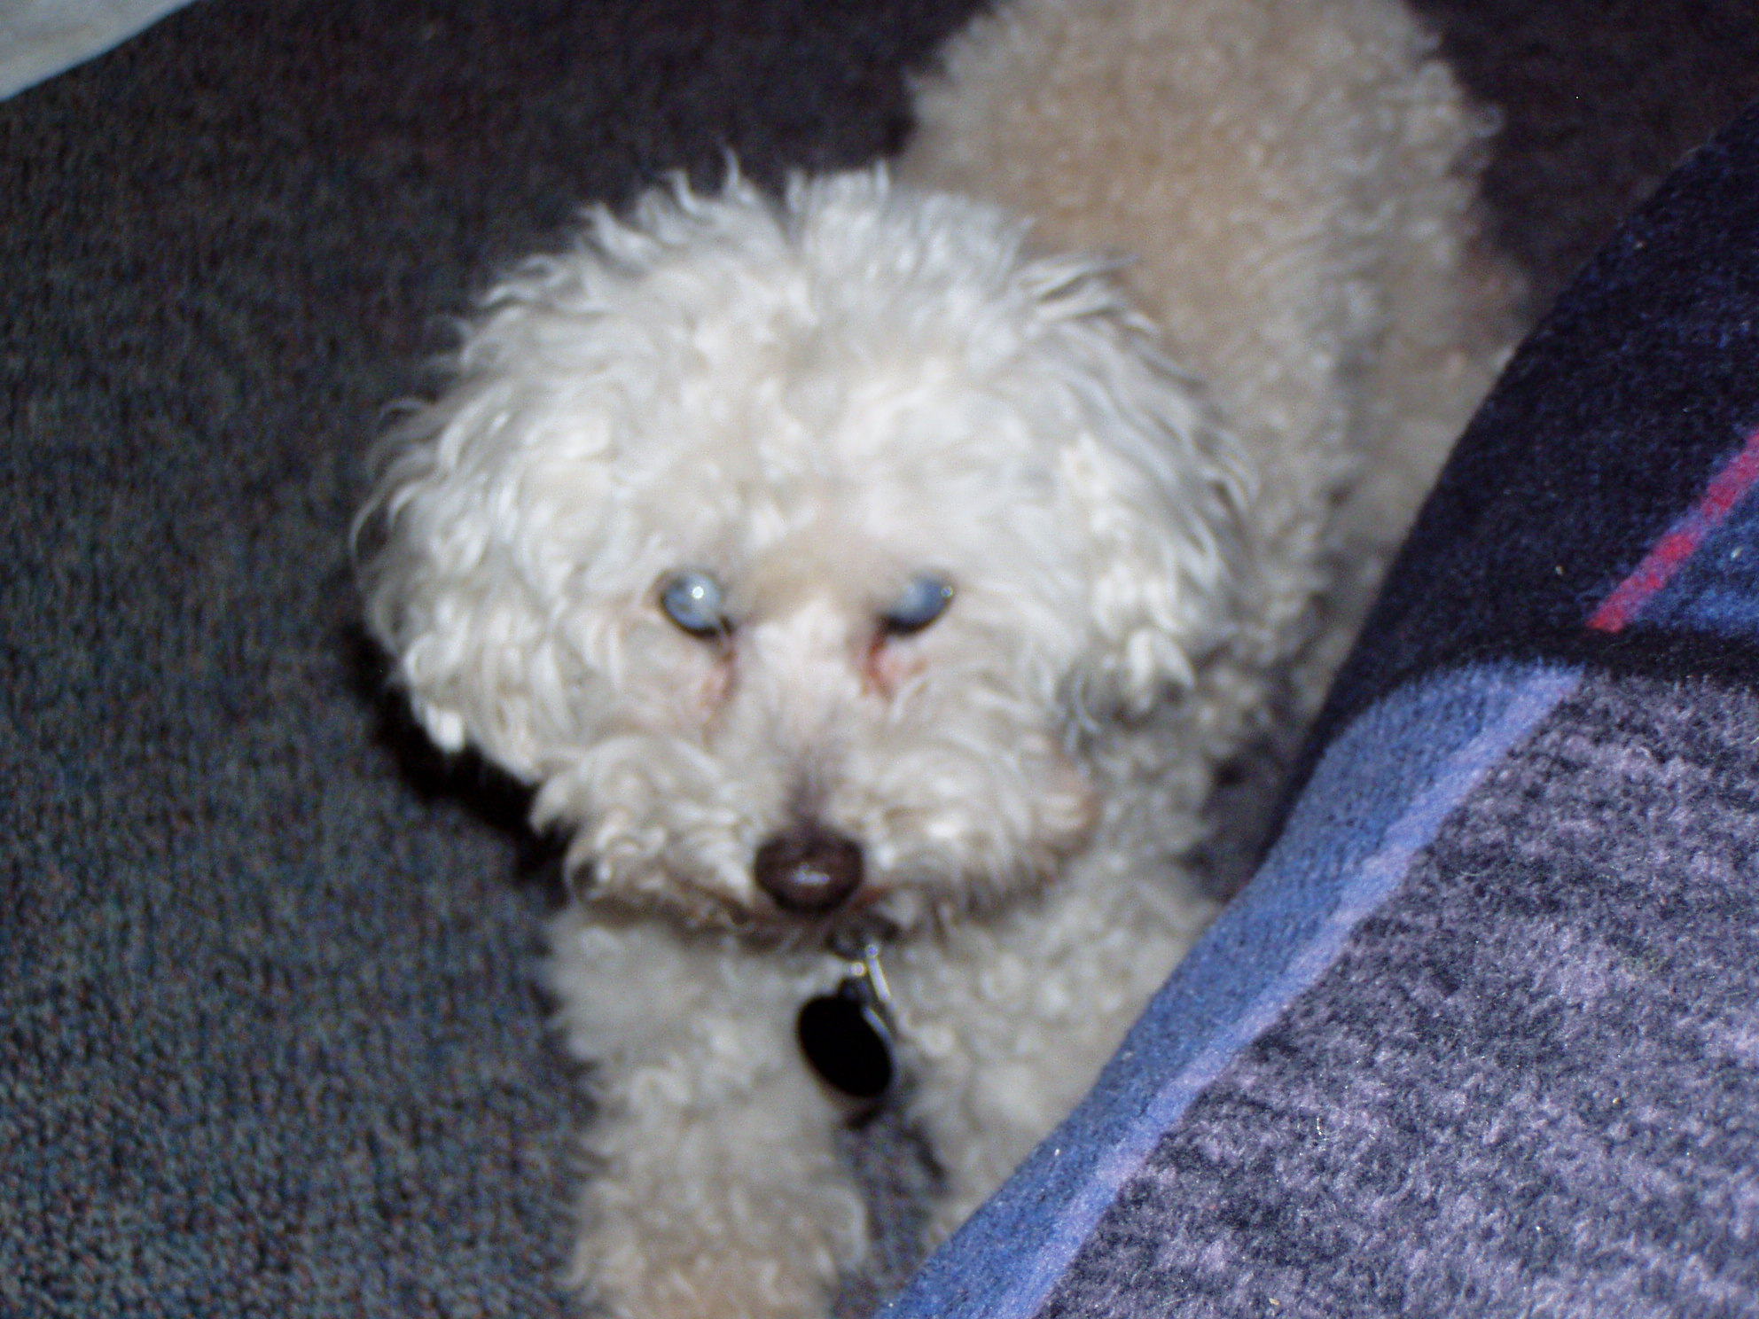
Scooch. The guy who stole my heart.
Please help Dr. Bera care for lost, injured and sick animals!
Click here to make a donation through Voice for a Choice!

