Nichaela
Blind, so badly abused and kicked around that she dragged her rear end, yet filled with love and a desire to share that love: that was our little Nichaela. She had been living a rough life on the streets for about 12 years by the time she found her way to us--and apparently had managed to swallow a seal while she was out there. Even though she weighed only about 12 pounds, we never heard a normal dog bark from her mouth; hers was strictly a seal bark. She had no teeth and her tongue hung out of her mouth all the time, but she was nonetheless sweet and loving with our family and the other dogs who came through our home, constantly bouncing around and being happy.
A sweet, independent, demanding Maltese-lhasa apso mix, Nichaela never caused fights, was forever curious, and always let us know when it was time for a meal--which she never missed, even though she acted like every one might be her last. Vets estimated she was about 19 when she passed away, but no one was sure. We felt honored to be able to care for her during the 7 years she lived with us.
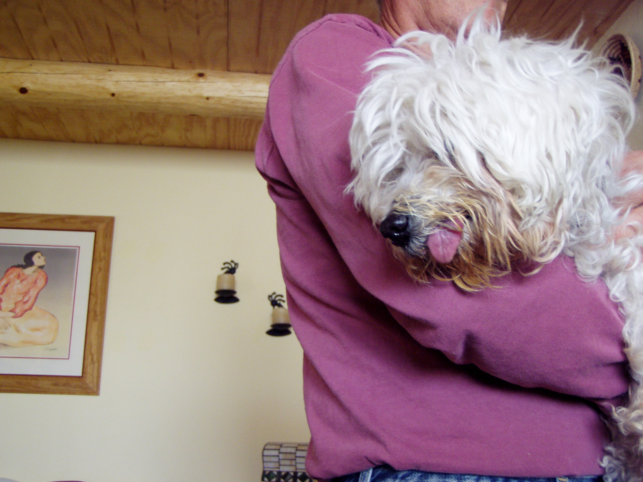
Please help Dr. Bera care for lost, injured and sick animals!
Click here to make a donation through Voice for a Choice!

