Rescuing Shania
She came to us blind in her one remaining eye, filled with breast-cancer tumors, and tettering on splayed feet from having lived in a puppy-mill wire cage for the first 8 years of her life. She'd given birth to 21 litters and was filled with bladder stones, one
the size of an egg that had to be surgically removed. The first year she lived with us she was terrified from her years of abuse at the hands of humans. Next week marks the two-year anniversary of our adopting Shania, this precious little bichon frise. How blessed we are to be able to share this precious one's life and hope to make the rest of it warm and loving.
Shania had only been with us a few weeks when we noticed that one of our
rescues was constantly urinating in the house. This had never happened before. Then we started noticing small stones in the urine and realized Shania was our culprit. We immediately began giving her a "crisis intervention" formula from Vibrant Health for
kidney/bladder support that includes cranberries to help keep bacteria from building up on her bladder's walls. She passed numerous stones, but still struggled, and could only pass a small amount of urine at a time. When we put her on a formula by Uriflow to break up the remaining stones, and her urine became cloudy as she passed what
appeared to be pulverized stones or sand. But then she started bleeding when she urinated. An x-ray showed the 25 mm "egg," which we had immediately removed.
During her "incarceration," Shania was fed a typical puppy-mill diet of byproduct foods--well below the quality we feed our dogs. And her health reflected her poor diet; in addition to the bladder stones, her fur was thin and dry. In our home she eats mostly raw meats, including organs and bones, and vegetables such as asparagus and parsley, which help cleanse the kidneys and bladder. She and her canine companions also eat eggs, legumes, fruits, very fine grains such as amaranth or quinoa and daily supplements including high-quality oat or wheatgrass, fish and/or coconut oil and colostrum. We judiciously ignored her surgeon's advice to feed her Prescription Diet canned dog, which is filled with byproducts and other cheap, nonfood substances.
To keep Shania from building up more bladder stones, we've kept her on the Uriflow formula, which helps pulverize small stones by breaking up the protein glue, thus keeping them from reforming. Although created originally for humans, the formula works beautifully on our canine companion, so we plan to keep her on it for life. Between the all-natural diet and the Uriflow formula, Shania has been clear of stones since her surgery nine months ago.
Since she lived in a cage for eight years, Shania's habits are less than acceptable in our home. I guess when a dog eats, sleeps, urinates and defacates all in the same small wire cage year after year, the "go where you are" habit is hard to break. Immediately after a meal she turns around and pees right where she just finished eating--obviously an organic brain problem we have not been able to cure. We don't like the situation, but we love her, so we devise doggie diapers out of infant diapers. They're much less expensive than purchasing doggie pads. Simply cut a hole where the tail goes.
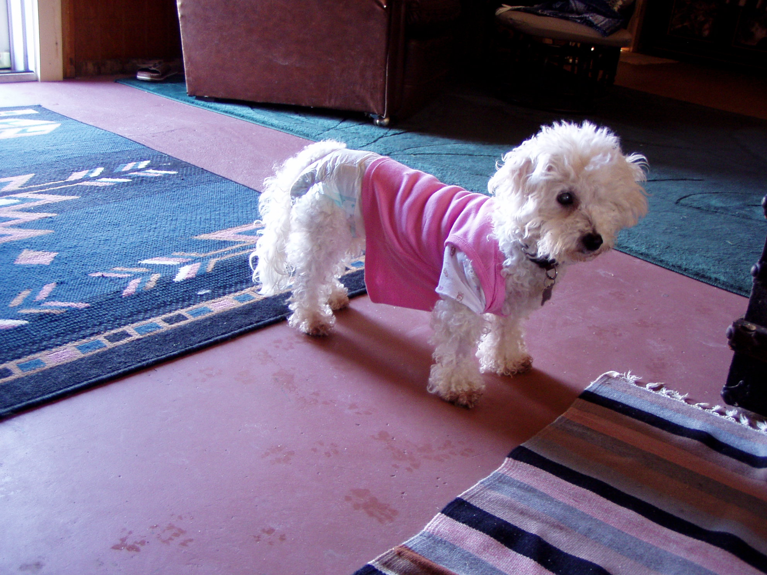 Ms. Shania in all her glory
Please help Dr. Bera care for lost, injured and sick animals!
Click here to make a donation through Voice for a Choice!

