Scooch
My precious little K'tahna had passed away and Kushi was left all alone in her blindness without her companion. She mourned, she grieved along with us. She missed her sister terribly and literally cried for her. It was imperative to find her another companion -- not a puppy, but an older companion. After weeks of searching through shelters for one appropriate to share her space, we got the call from east L.A. telling
us about a blind bichon who needed a home. Male. For some reason I wanted only to have another sweet little female, but that wasn't to be.

Enter Scooch. Minutes after meeting him we knew he would be the perfect companion for Kushi. They kissed the minute they met, and we were all smitten: Ron, myself, and especially Kushi.
All my life I've lived with dogs, but never one quite like Scooch. He was magical. People would walk into our home and say they didn't like dogs, and within minutes they'd be holding Scooch. He had a way about him like no other dog I've ever met. He was infused with a spirit so loving and healing that after meeting him only once or twice, people would seek him out. We work with a lot of ill people, and Scooch always knew when someone needed his energy, even if he had never met them before. He automatically went up to whoever who was ill and started sharing his love. He lived with us exactly 7 years before he went into seizures and departed this world. Truly one of the most difficult days of my life to date.
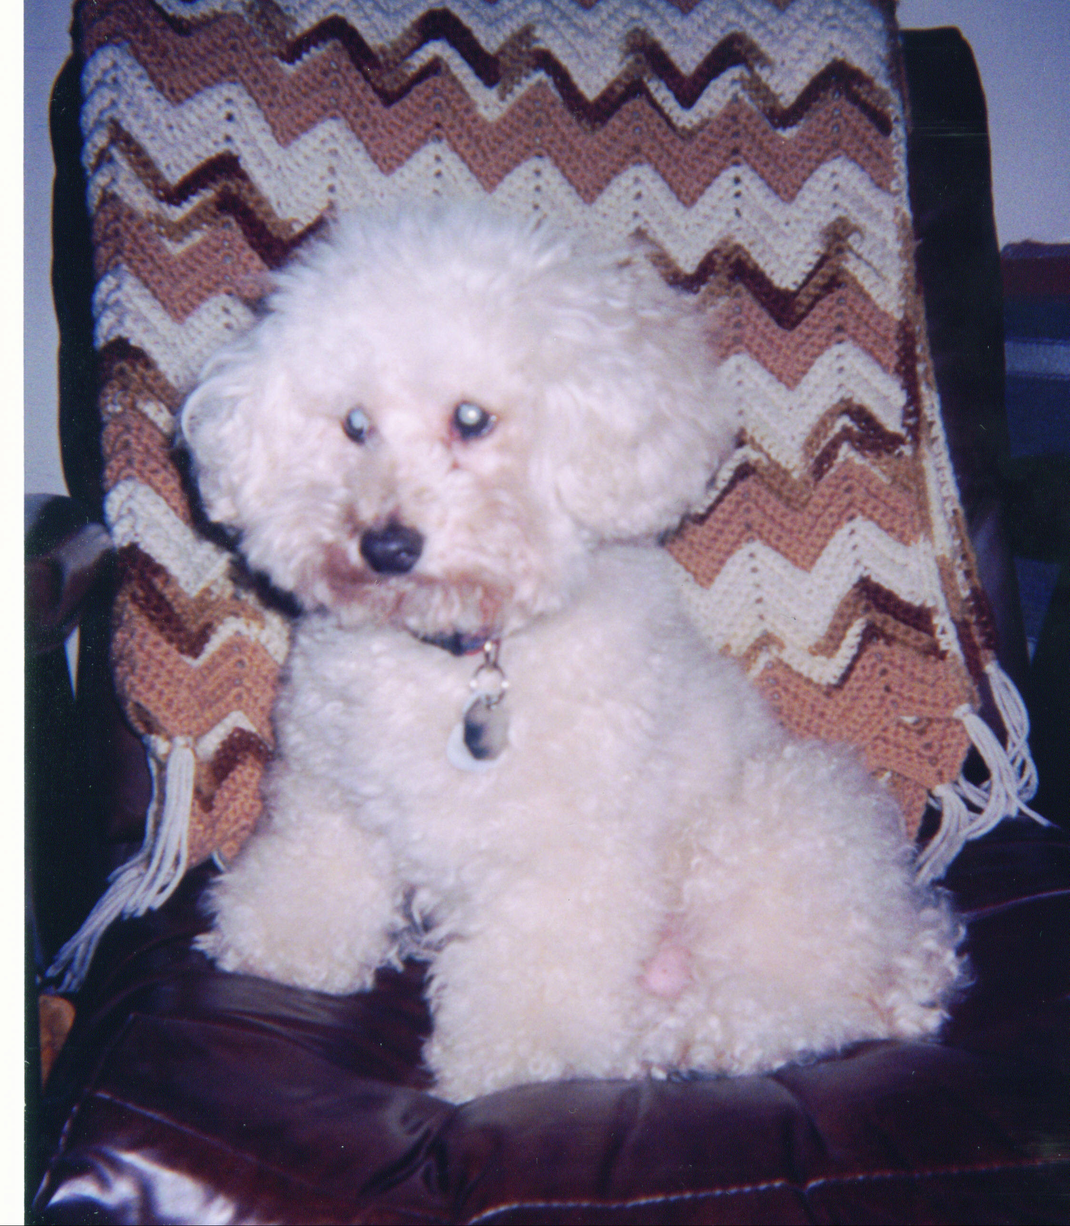 Scooch, Chairman of the Board
Please help Dr. Bera care for lost, injured and sick animals!
Click here to make a donation through Voice for a Choice!

