Wylie
"Why did you just throw him out your window?" the rescuer asked the man she saw throw Wylie out his car window in the Sandia Mountains just outside Albuquerque.
"His legs are no good. Better to let the coyotes have a good meal than keep him."
Such is the ignorance we see every day. Some people seem to think they have the
right to do whatever they want with an animal because "it's only an animal" or "it's just a dog." We feel fortunate when these precious lives intertwine with ours and we get to be blessed with their presence. In fact, we're honored to have all the special-needs dogs we have in our home--honored we have the opportunity to work with them and do what we can to improve the quality of their lives.
When Wylie's rescuer brought him to us back in 2001, he was all of 3-pounds and his little hind legs wobbled when he stood. That was it--my heart was his, big time. In fact, he slept on my chest listening to my heart all that first night long. Ah, yes, we bonded.
Most likely a product of "backyard breeding," Wylie was born without any kneecaps or hip joints. He walks and runs, but tires easily and quickly. Following Cesar Millan's edict of taking him for long walks to exhaust him is not an option; we usually end up carrying him on the way home. Vets have advised putting pins in his legs, but we know surgery could cause arthritis when he gets older.
So three to four times a week he receives massage and/or body therapy to keep his legs working. Although he looks like he's about to pee or poop whenever he's standing, he continues to get around remarkably well. With a little assistance from ramps and strategically placed steps, he can get up on couches, climb onto beds, and run and play, just like his able-bodied brothers and sisters. Nothing stops Wylie from having a good time!
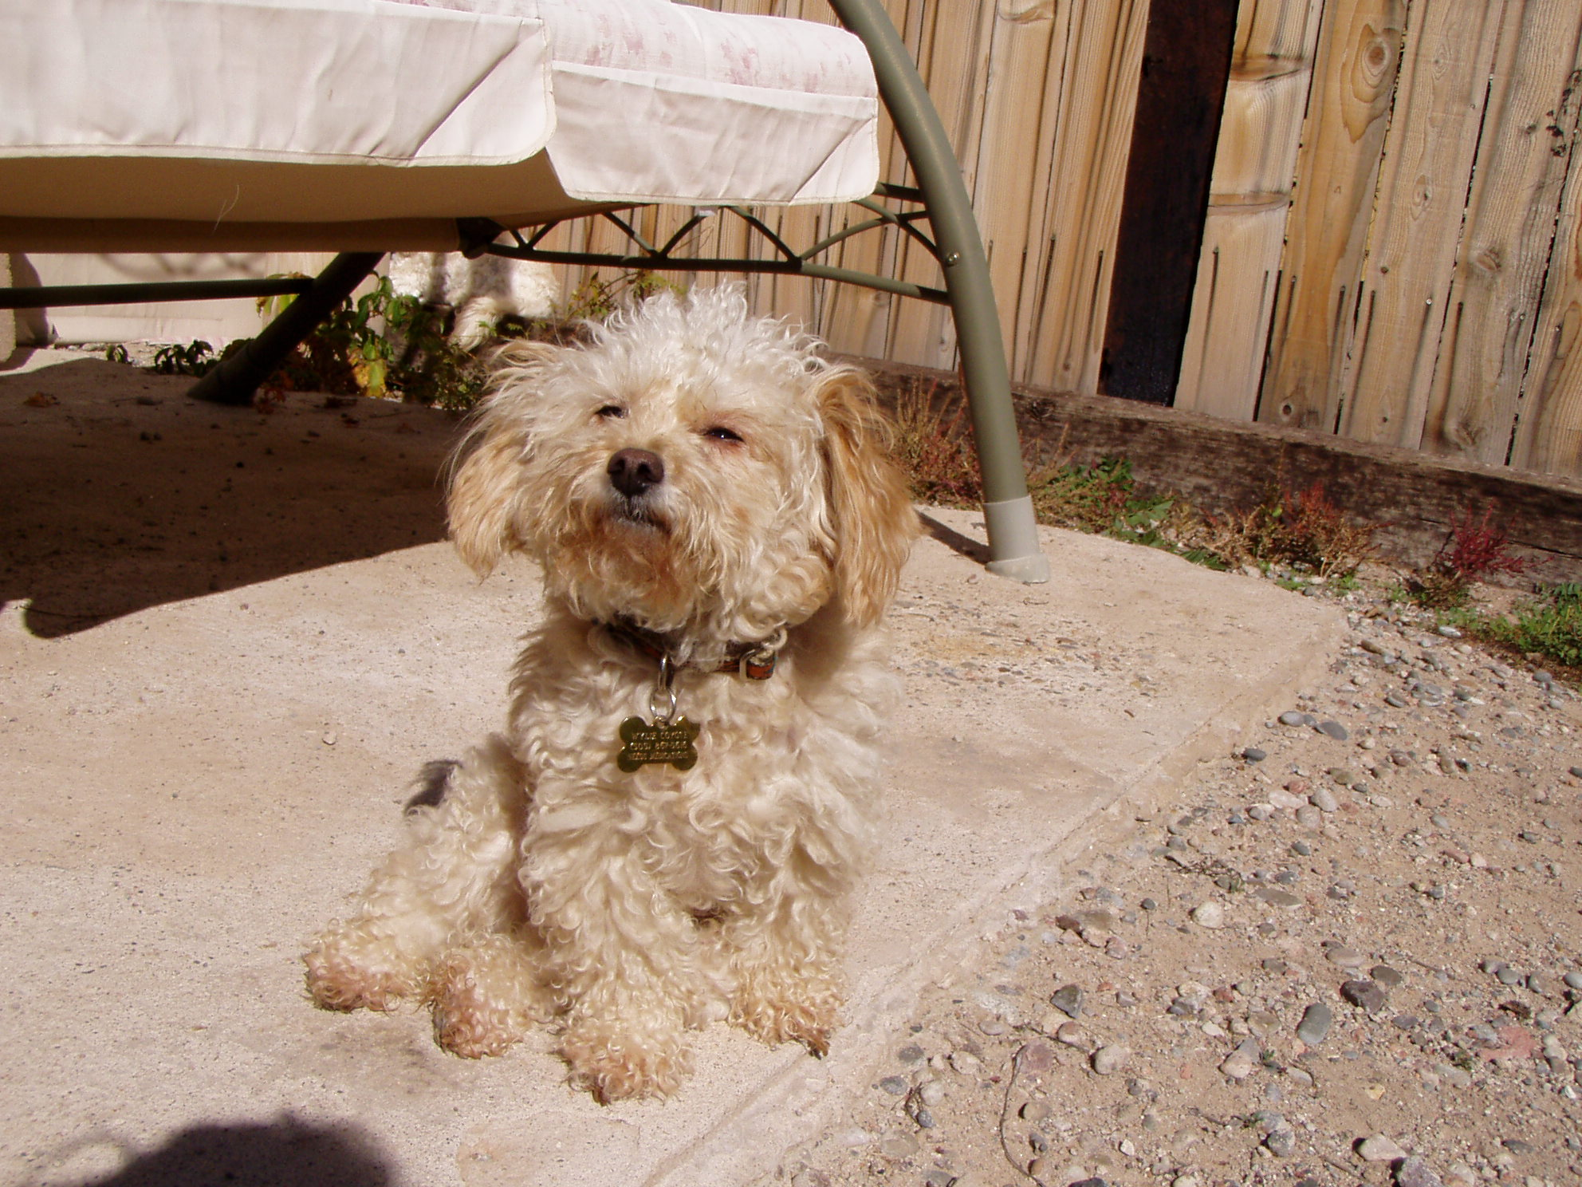
Sun worshipping 'Wylie Coyote'
Please help Dr. Bera care for lost, injured and sick animals!
Click here to make a donation through Voice for a Choice!

