Zeus
My father-in-law, Frank, left the east coast after losing his wife and moved in
with Ron and me so we could take care of his congestive heart failure and Alzheimer's. None of the special-needs dogs we had at the time could jump into his lap and love him, so he asked for a dog of his own.

At about the same time, LapDog Rescue called about a very frightened poodle mix who had been found wandering the streets in southwest Albuquerque. Nothing was wrong with him--he'd previously broken his left rear leg, but it had healed. He had been placed in a home with three Jack Russell Terriers, but they terrorized him, so he had been returned to LapDog.

We took Frank to meet Zeus at Three-Dog Bakery--and Zeus jumped directly into Frank's lap. Even though he didn't really have any special needs except his fear, we knew he was destined to come home with us.
Obedient, loving and an absolute pleasure to have in our home, Zeus gets along beautifully with his canine brothers and sisters and lives to love, play and be loved.
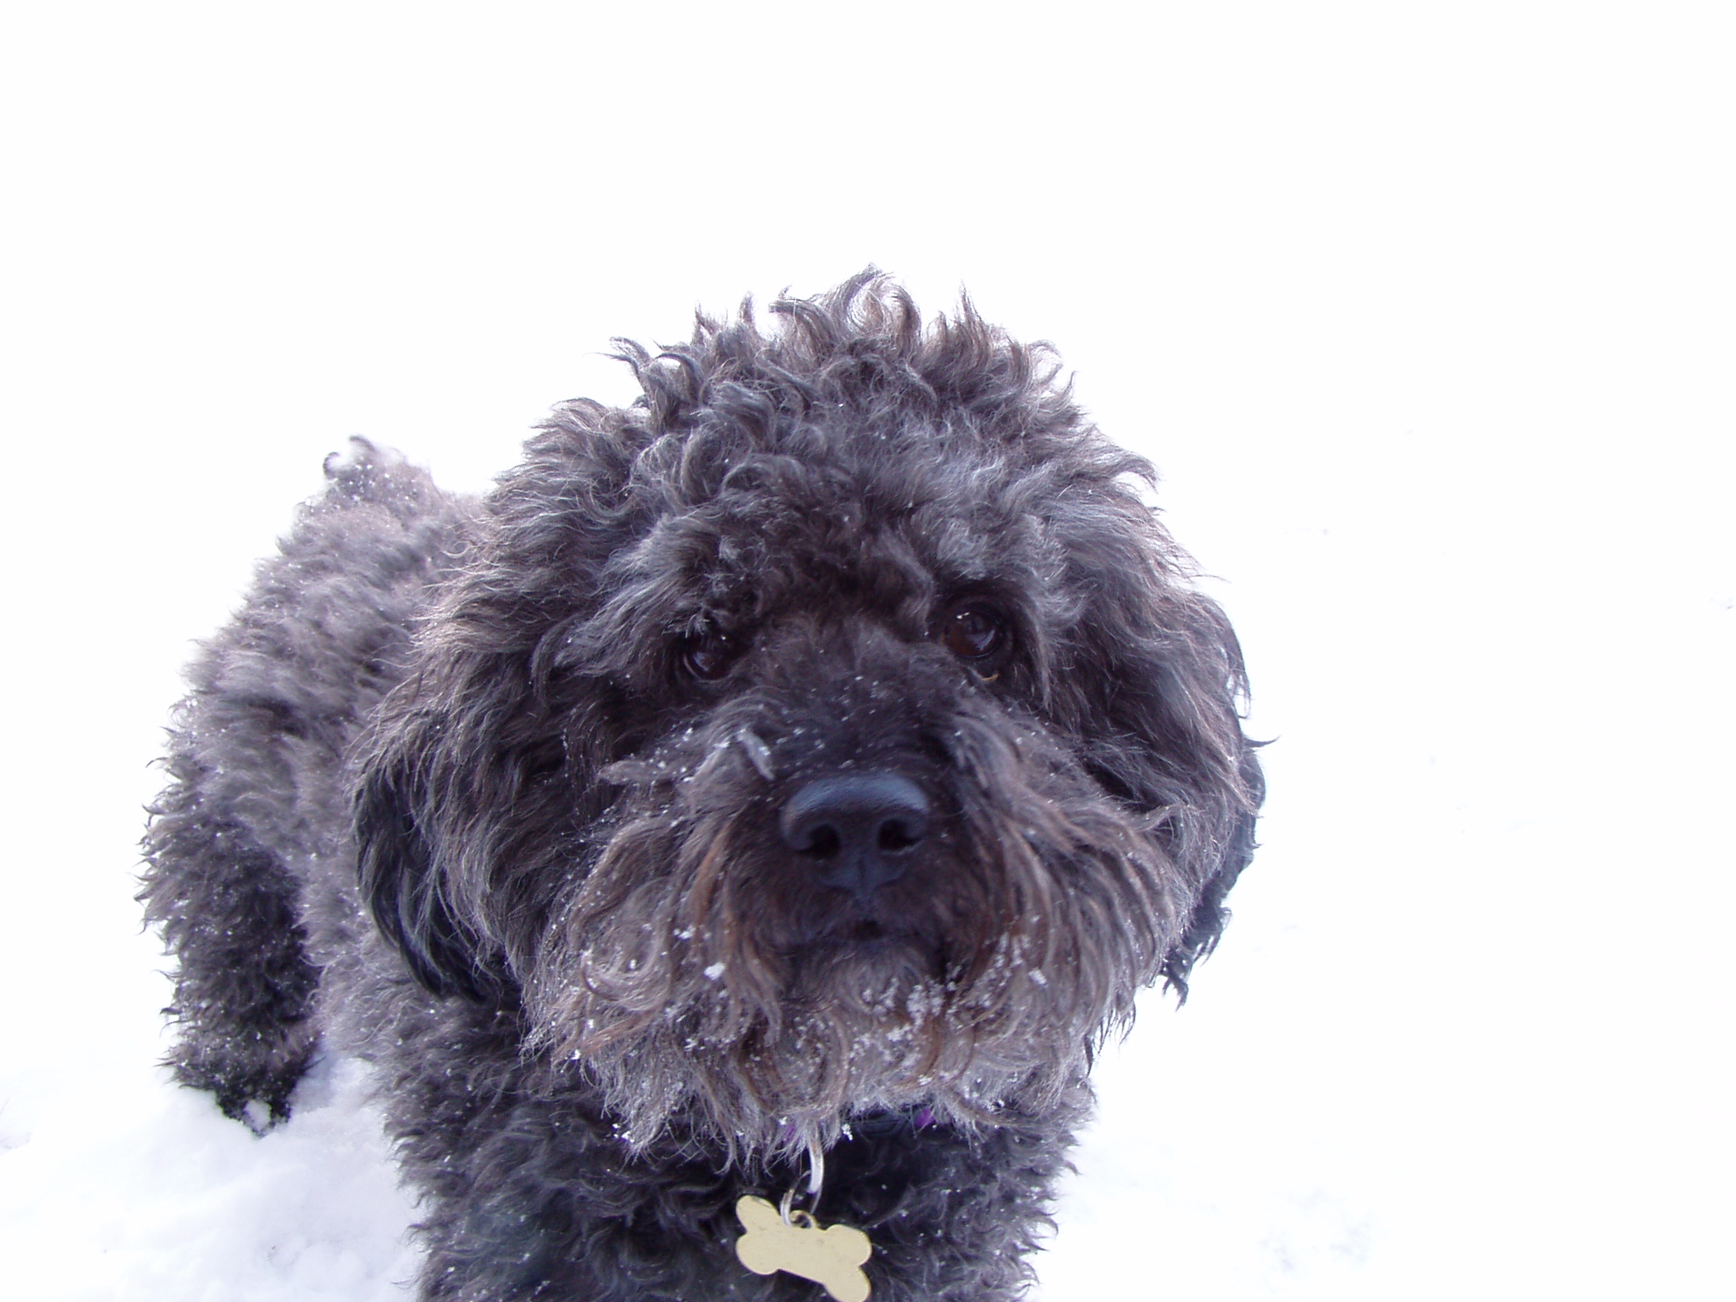 Zeus playing in the snow
Please help Dr. Bera care for lost, injured and sick animals!
Click here to make a donation through Voice for a Choice!

